WE GIVE BACK TO YOUR SCHOOL OR ORGANIZATION!!!
www.hairpoliceliceline.com
PREVENTION TO ELIMINATION…“WE ARE IN IT TO WIN IT” WITH YOU!
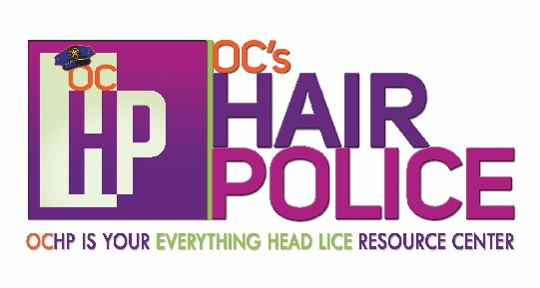
CALL OR EMAIL TODAY
FOR DETAILS!!
949.631.2675
lousearreast@hairpoliceliceliceline.com

10% OF YOUR PREVENTION AND/OR ELIMINATION PRODUCT PURCHASE WILL BE DONATED TO_____________! Upon product purchase, please provide us with an image of this flyer…

Spread the word not the lice!

